Lab Exercise 4

[Based on Python data types, conditional statements & Loops]

Q1: Write a python program to add all the odd numbers from 0 to 20.
sum = 0
for number in range(21):
if number % 2 != 0:
sum += number
print("The sum of all odd numbers from 0 to 20 is:", sum)

Q 2: Write a python program to find the sum of all integers greater than 100 and less than 200.
sum = 0
for number in range(101, 200):
sum += number
print("The sum of all the numbers greater than 100 ad less than 200 is:", sum)

Q3: Write a program to display the sum of square of the first ten even natural numbers
sum = 0
for number in range(2, 21, 2):
sum += number ** 2
print("The sum of the squares of the first ten even natural numbers is:", sum)

Q4: Write a python program to display ascii characters from 65 to 90
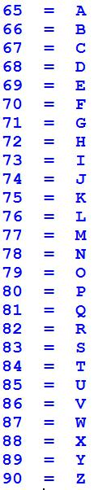

for number in range(65, 91):
print(f"{number}: {chr(number)}")

Q5: Display ascii characters from 48 to 57.

for number in range(48, 58):
print(f"{number}: {chr(number)}")

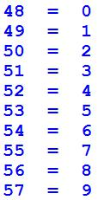

Q6: Display the following output with the help of Ascii character.
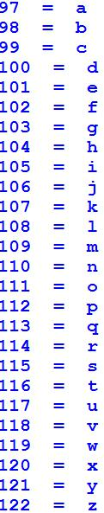

for number in range(97, 122):
print(f"{number}: {chr(number)}")

Q7: Write a python program for given a Python list you should be able to display Python list in the reverse order

L1 = [100, 200, 300, 400, 500]

Expected output:

[500, 400, 300, 200, 100]

L1 = [100, 200, 300, 400, 500]
L1_reversed = L1[::-1]
print("Reversed List:", L1_reversed)

Q8: Write a Python program to concatenate following dictionaries to create a new one.
Sample Dictionary :
dic1={1:10, 2:20}
dic2={3:30, 4:40}
dic3={5:50,6:60}
Expected Result : {1: 10, 2: 20, 3: 30, 4: 40, 5: 50, 6: 60}

dic1={1:10, 2:20}
dic2={3:30, 4:40}
dic3={5:50,6:60}
final = {**dic1, **dic2, **dic3}
final_dic = dict(sorted(final.items()))
print("the desired output is ", final_dic)

Q9: Write a Python program to add key to a dictionary.
Sample Dictionary : {0: 10, 1: 20}
Expected Result : {0: 10, 1: 20, 2: 30}

sample_dict = {0: 10, 1: 20}
new_key = 2
new_value = 30
sample_dict[new_key] = new_value
print("Updated Dictionary:", sample_dict)

Q10: Write a Python program to print out a set containing all the colors from a list which are not present in another list
Test Data :
color_list_1 = set(["White", "Black", "Red"])
color_list_2 = set(["Red", "Green"])

color_list_1 = set(["White", "Black", "Red"])
color_list_2 = set(["Red", "Green"])
difference_set = color_list_1 - color_list_2
print("Colors in color_list_1 that are not in color_list_2:", difference_set)

Q11: Given a Python list. Write a python program to turn every item of a list into its square
List1 = [1, 2, 3, 4, 5, 6, 7]
Expected output:

[1, 4, 9, 16, 25, 36, 49]

List1 = [1, 2, 3, 4, 5, 6, 7]
squared_list = [x ** 2 for x in List1]
print("Squared List:", squared_list)

Q12: Program to count the number of each vowel in a string.
input_string = input("Enter a string: ")
vowels = 'aeiou'
vowel_counts = {vowel: 0 for vowel in vowels}
input_string = input_string.lower()
for char in input_string:
if char in vowel_counts:
vowel_counts[char] += 1
print("Vowel counts:", vowel_counts)

Q13: Write a python program to Access the value of key ‘history’ from the following dictionary-sampleDict = {

"class":{
"student":{
"name":"Mike",
"marks":{
"physics":70,
"history":80
}
}
}
}

sampleDict = {
"class": {
"student": {
"name": "Mike",
"marks": {
"physics": 70,
"history": 80
}
}
}
}
history_score = sampleDict["class"]["student"]["marks"]["history"]
print("The history score is:", history_score)

Q 14: write a Program to Remove Punctuations from a String provided by the user. [Hint: use punctuation attribute of string module to get all punctuations (i.e. !"#$%&\'()*+,-./:;<=>?@[\\]^_`{|}~ ) ]

import string
input_string = input("Enter a string: ")
translator = str.maketrans('', '', string.punctuation)
cleaned_string = input_string.translate(translator)
print("String without punctuation:", cleaned_string)

Q15: write a Program to sort alphabetically the words form a string provided by the user. [You can use split() method to split string into a list of words. ]

input_string = input("Enter a string: ")
words = input_string.split()
words.sort()
sorted_string = ' '.join(words)
print("Sorted words:", sorted_string)

[Nested Loops]

Q16: Write a python program to print the Following:
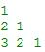
1
2 1
3 2 1

num_rows = 3
for i in range(1, num_rows + 1):
for j in range(i, 0, -1):
print(j, end=' ')
print()

Q17: WAP to print the following asterisk pattern:
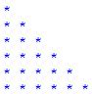

num_rows = int(input("Enter the number of rows: "))
for i in range(1, num_rows + 1):
print('* ' * i)

Q18: WAP to create a function traiangle to print the following asterisk triangle pattern:
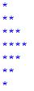

num_rows = int(input("Enter the number of rows: "))
for i in range(1, num_rows + 2):
print('* ' * i)
for i in range(num_rows, 0, -1):
print('* ' * i)

Q19: Write a python program to print following multiplication table on the screen

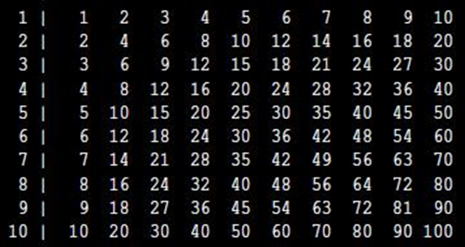

size = int(input("Enter the size of the multiplication table: "))
header = " "
for j in range(1, size + 1):
header += f"{j:4}"
print(header)

for i in range(1, size + 1):
row = f"{i:2} "
for j in range(1, size + 1):
row += f"{i * j:4}"
print(row)

